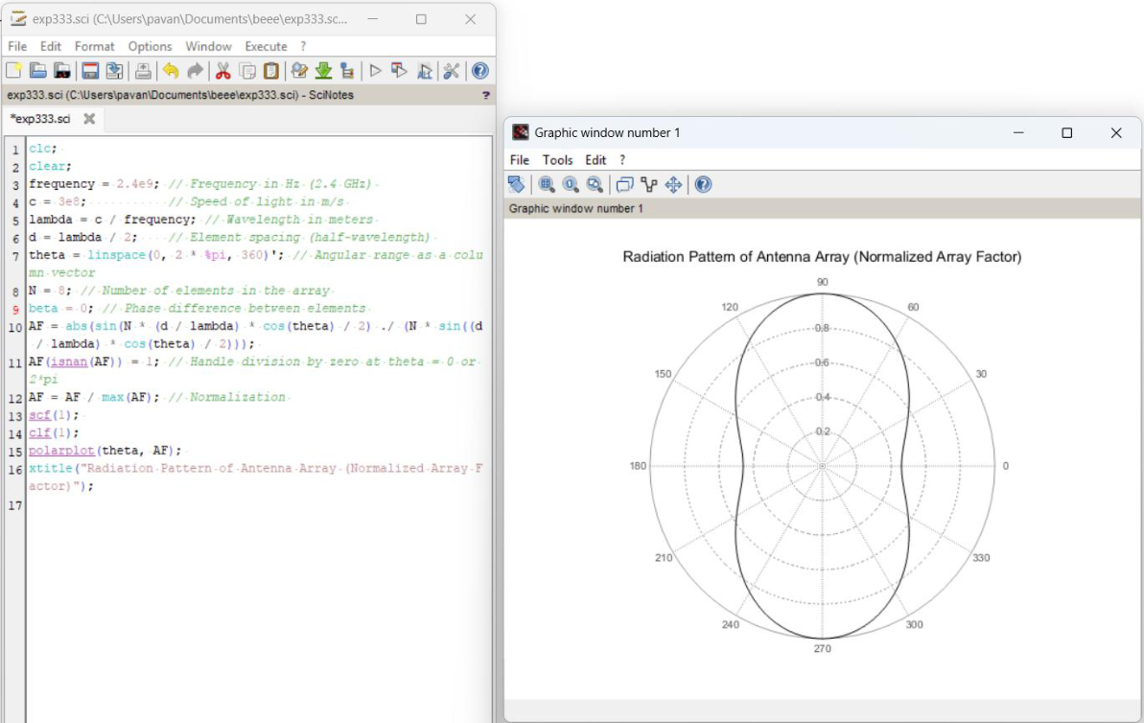

EXP NO:16
Determination and plotting of Radiation Pattern for a
uniform linear array

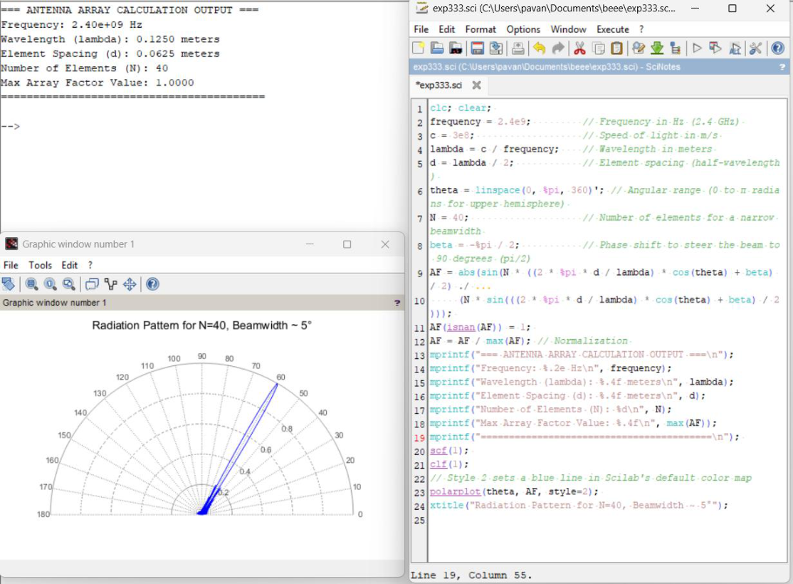

CASE:1
Optimization of Beamwidth for High-Resolution RADAR Systems

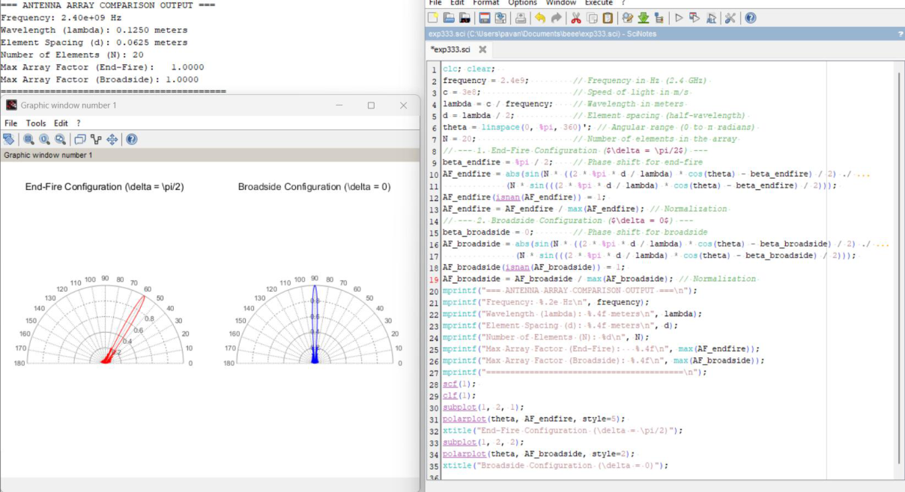

CASE:2 End-Fire Radiation for Wireless Communications

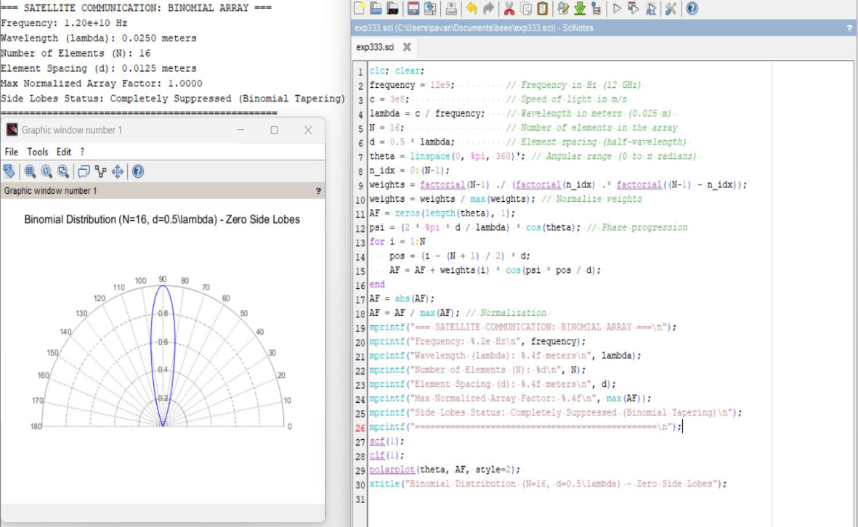

case 3: Minimizing Side Lobes for Satellite Communication.

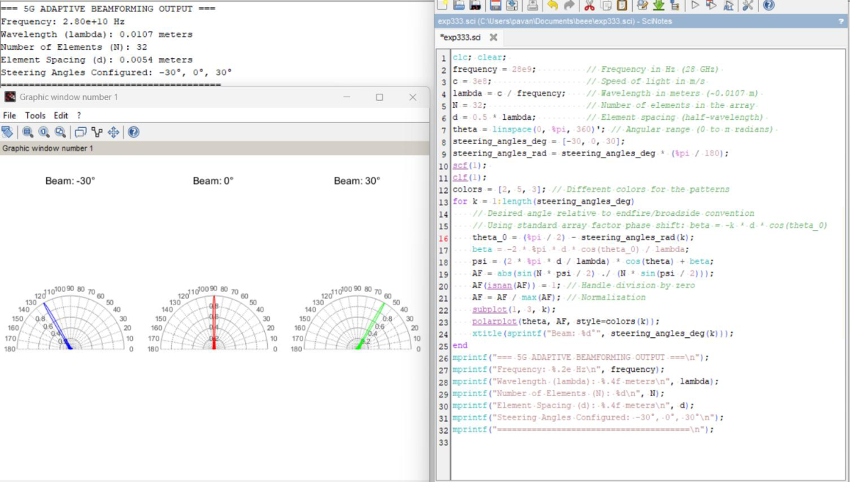

CASE:4 Adaptive Beamforming for 5G Networks

